Assignment 2 –DW
Student Name: SUMMANDEEP (Revised)

Table of Contents
TASK1 – Data Integration (ETL) and Maintenance 4
1.1 Original datasets 4
Screenshot 1: creating databases in APEX 4
TWO DB Evidence 4
Evidence code of creating my table: 4
Crime dataset search query 5
1.2 Star Schema 6
Aggregate Function in APEX 7
Count () 7
Count another query 7
Sum() 8
AVG() 8
MIN() 9
Max() 9
Group by () 10
Evidence Code 10
Table crime _ Rec 10
CREATE TABLE "CRIME_DATA_LEEDS_2018_2020" 10
Evidence code of aggregate function in apex 11
Data Dictionary Table 12
1.3 Staging Area 13
Staging Area steps 13
1.3.1 Extracting of data into a temp table? 13
Cleaning of data 14
Transforming of data 15
2. TASK 2 - OLAP 18
Crime data Leeds chart 18
PIVOT Table in Excel 19
3. TASK 3 – Findings and Reflection 20
PAPA framework 20
Privacy 20
Accuracy 20
Property 21
Accessibility 21
Bibliography 21
Appendixes – add of your APEX code here 22

TASK1 – Data Integration (ETL) and Maintenance

1.1 Original datasets
The research going to uses the PCRS and the original dataset which has provided, it contains the multiple tables such as PL Area, station, PL crime type. The columns values contains the dataset which present the department which generate reports of the stakeholder to obtain the crimes records from the database to achieve the integration process of ETL which created as part of ETL data marts and which feed in star schema.

Screenshot 1: creating databases in APEX

TWO DB Evidence
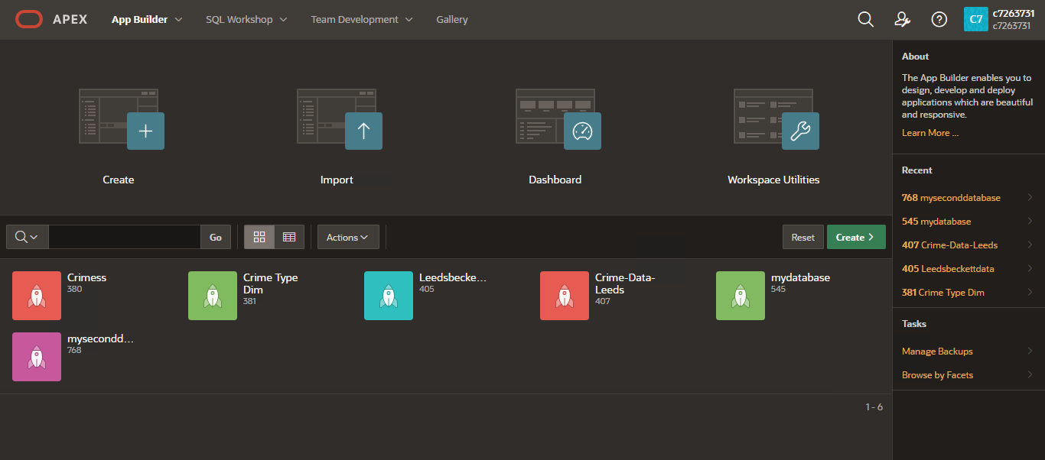
- Do you need to grow data in your table, or you have got a sufficient number of rows… Do it only if you know how to, otherwise it does not matter.

Evidence code of creating my table:
create table CRIME_REC (
THEFT varchar2(10),
BURGLARY varchar2(10),
weight integer
);
insert into CRIME_REC values ( 'GOLD', 'UK', 1 );
insert into crime_rec values('leather','manchester',2);
insert into crime_rec values('iron','Leeds',3);

select *from crime_rec;

Crime dataset search query

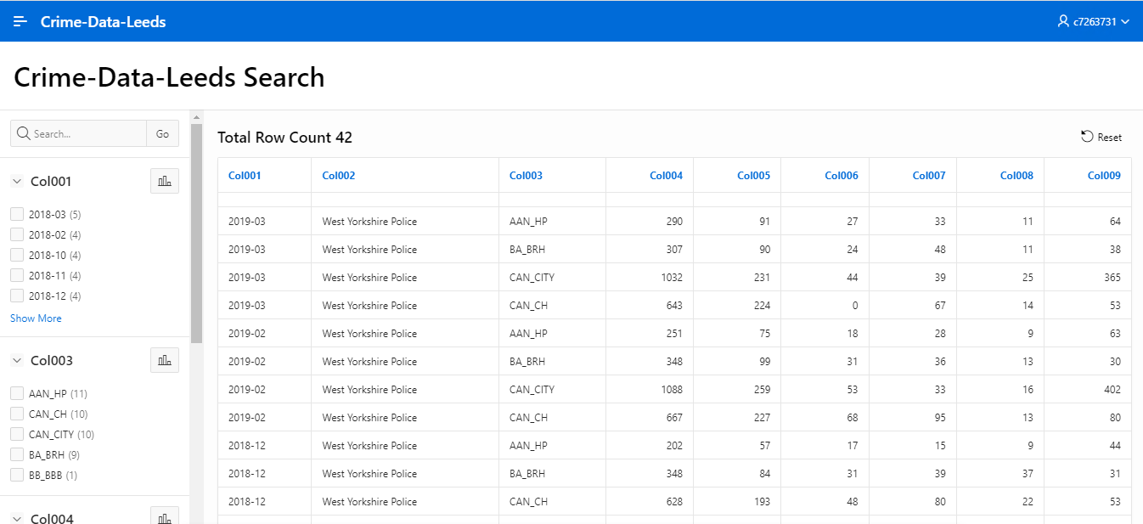
Evidence code, brief discussion and screenshot that it is running successfully

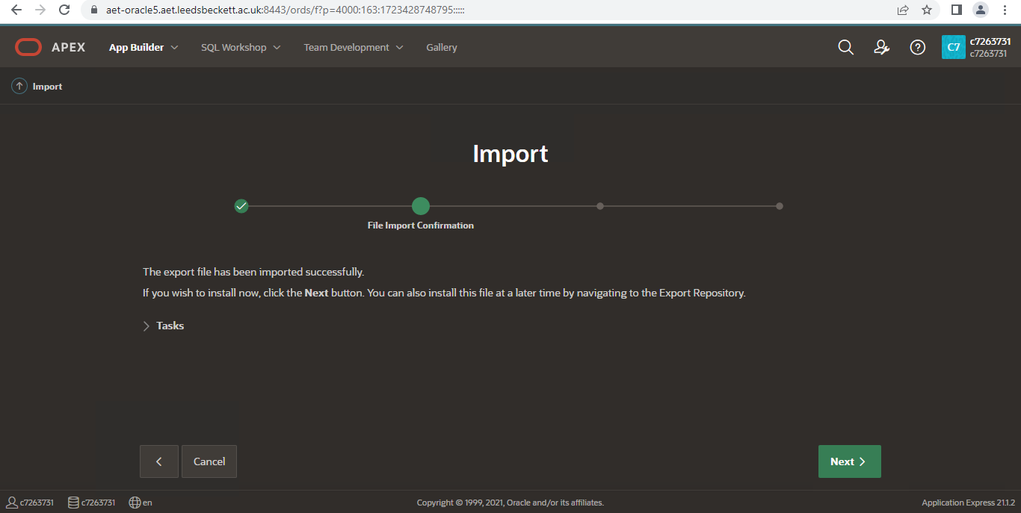

1.2 Star Schema

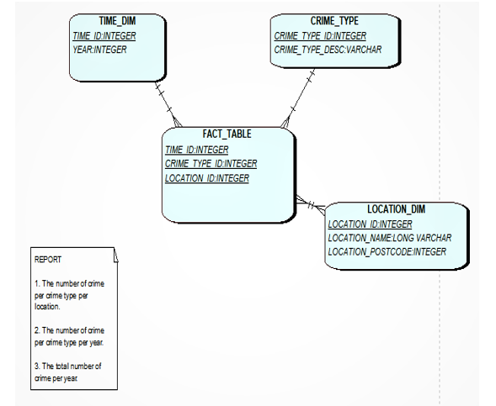

- Have you got a surrogate key(s) in your dimension? Will you implement a sequence for your surrogate keys or natural keys?
There is no need to mention the surrogate key in the table because already prime key is there.
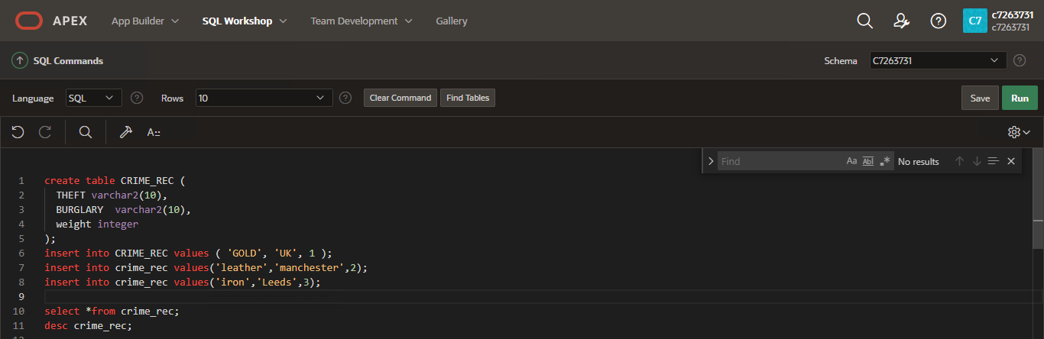
- Consider your measures for your reports, such as Avg xyz in a location, total, min… more aggregates…

Aggregate Function in APEX

Count ()
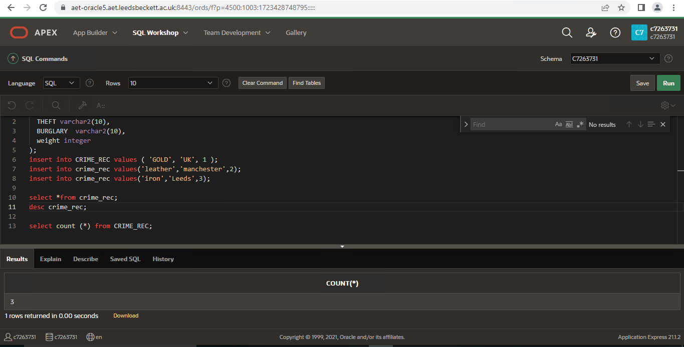

Count another query

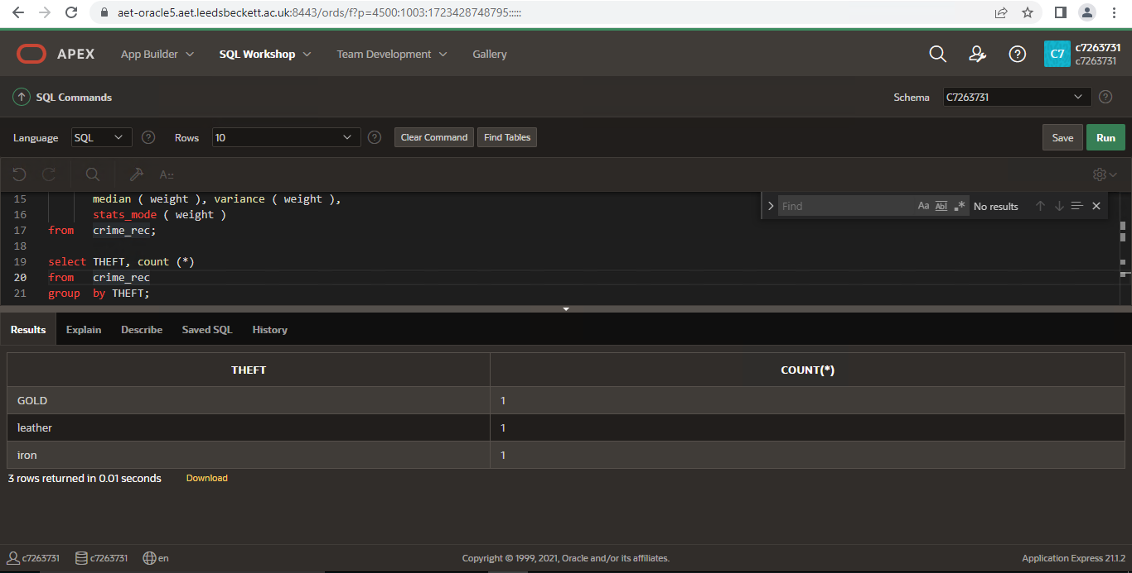

Sum()

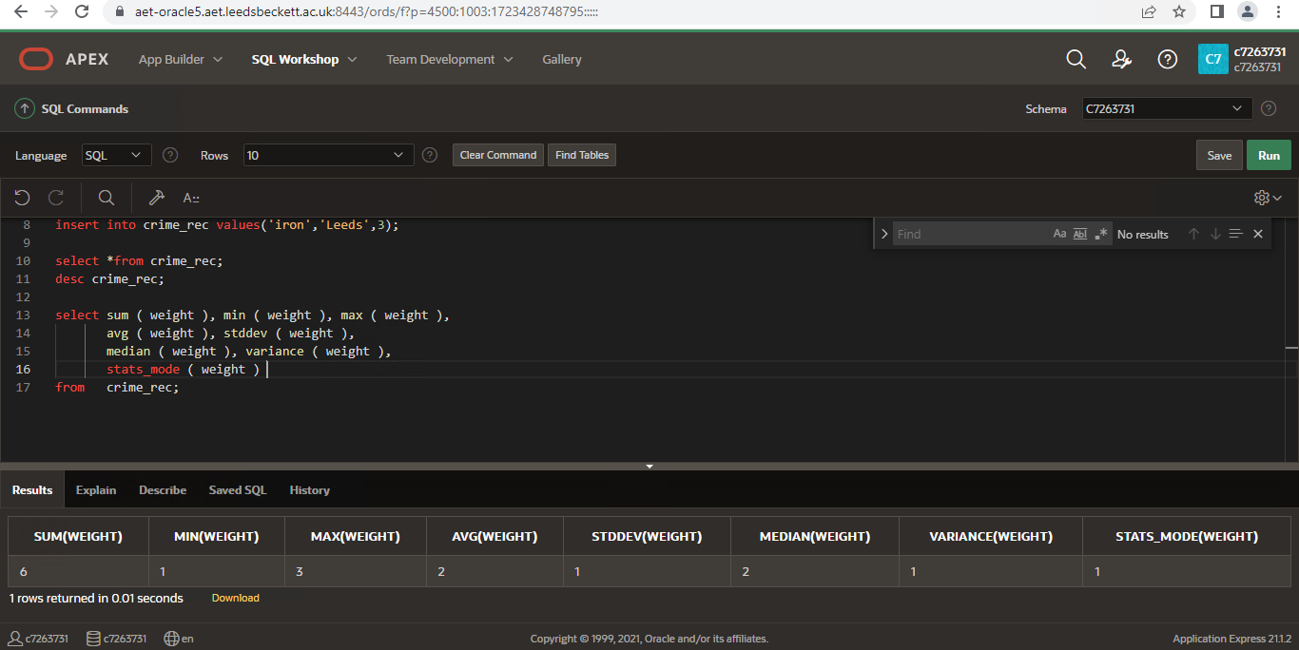

AVG()

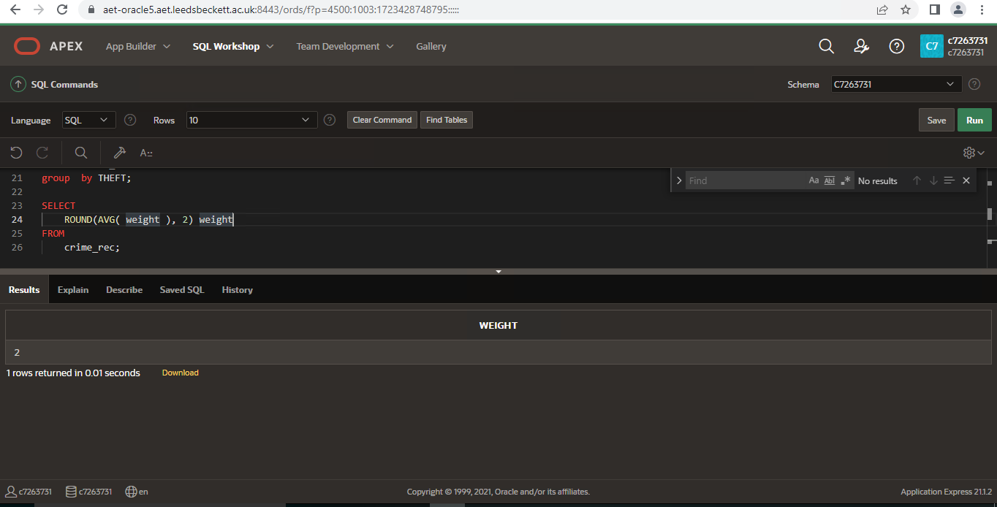

MIN()
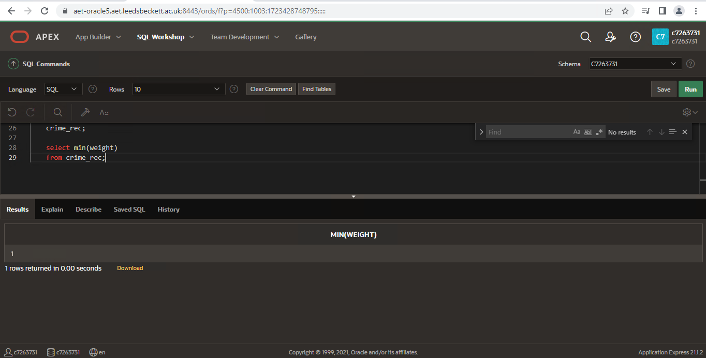

Max()
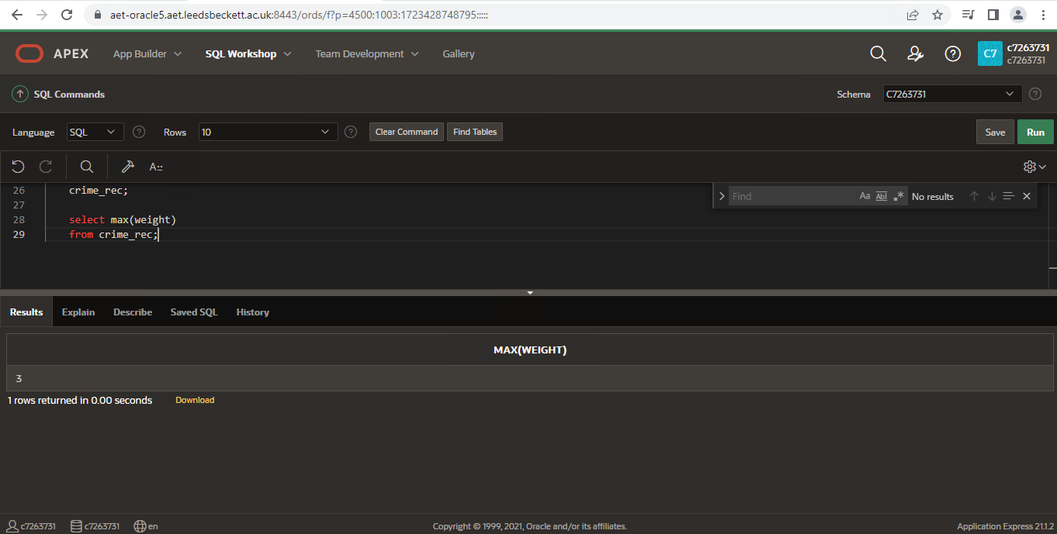

Group by ()
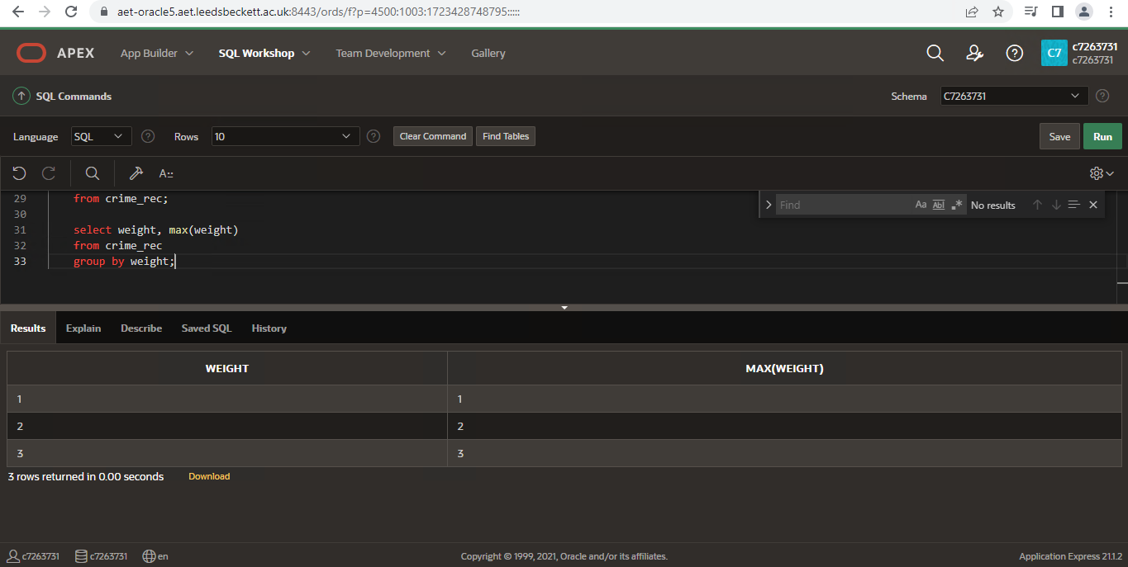

Evidence Code

Table crime _ Rec

create table CRIME_REC (
THEFT varchar2(10),
BURGLARY varchar2(10),
weight integer
);
insert into CRIME_REC values ( 'GOLD', 'UK', 1 );
insert into crime_rec values('leather','manchester',2);
insert into crime_rec values('iron','Leeds',3);

select *from crime_rec;
desc crime_rec;

CREATE TABLE "CRIME_DATA_LEEDS_2018_2020"
( "ID" NUMBER GENERATED BY DEFAULT ON NULL AS IDENTITY MINVALUE 1 MAXVALUE 9999999999999999999999999999 INCREMENT BY 1 START WITH 1 CACHE 20 NOORDER NOCYCLE NOKEEP NOSCALE NOT NULL ENABLE,
"MONTH" VARCHAR2(50),
"FORCE" VARCHAR2(50),
"NEIGHBOURHOOD" VARCHAR2(50),
"ALL_CRIME" NUMBER,
"ANTI_SOCIAL_BEHAVIOUR" NUMBER,
"BURGLARY" NUMBER,
"CRIMINAL_DAMAGE_AND_ARSON" NUMBER,
"DRUGS" NUMBER,
"OTHER_THEFT" NUMBER,
"PUBLIC_DISORDER_AND_WEAPONS" NUMBER,
"ROBBERY" NUMBER,
"SHOPLIFTING" NUMBER,
"VEHICLE_CRIME" NUMBER,
"VIOLENT_CRIME" NUMBER,
"OTHER_CRIME" NUMBER,
PRIMARY KEY ("ID")
USING INDEX ENABLE
)

Evidence code of aggregate function in apex
create table CRIME_REC (
THEFT varchar2(10),
BURGLARY varchar2(10),
weight integer
);
insert into CRIME_REC values ( 'GOLD', 'UK', 1 );
insert into crime_rec values('leather','manchester',2);
insert into crime_rec values('iron','Leeds',3);

select *from crime_rec;
desc crime_rec;

select sum ( weight ), min ( weight ), max ( weight ),
avg ( weight ), stddev ( weight ),
median ( weight ), variance ( weight ),
stats_mode ( weight )
from crime_rec;

select THEFT, count (*)
from crime_rec
group by THEFT;

SELECT
ROUND(AVG( weight ), 2) weight
FROM
crime_rec;

select min(weight)
from crime_rec;

Data Dictionary Table
Data Dictionary Table
Field Name | Data type | SIZE
Month | Number INTEGER | 10
Force | Number INTEGER | 10
Neighborhood | Number INTEGER | 10
All Crime | Number INTEGER | 10
Anti-social behavior | Number INTEGER | 10
Burglary | Number INTEGER | 10
Criminal damage and arson | Number INTEGER | 10
Drugs | Number INTEGER | 10
Other theft | Number INTEGER | 10
Public disorder and weapons | Number INTEGER | 10
Robbery | Number INTEGER | 10
Shoplifting | Number INTEGER | 10
Vehicle crime | Number INTEGER | 10
Violent crime | Number INTEGER | 10
Other crime | Number INTEGER | 10

Staging Area

Answer: the staging area or landing zone is an intermediate storage area used for data processing during the extract transform and load (ETL) processing, while the data staging area sits between the data source and the data targets which are often data warehouses, data marts, or other data repositories.
In data warehousing using Apex the extract transform and load process staging sits between the data sources and the data targets which often data warehouse using the data mart technique to make database in more meaningful to understand by splitting them into pieces of data mart shape. Such as data mart considered as Criminal dataset divided and split into different chunks for producing more meaningful investigation to police officials.

Staging Area steps

- Extract
- Transform
- Load
- Data Mart
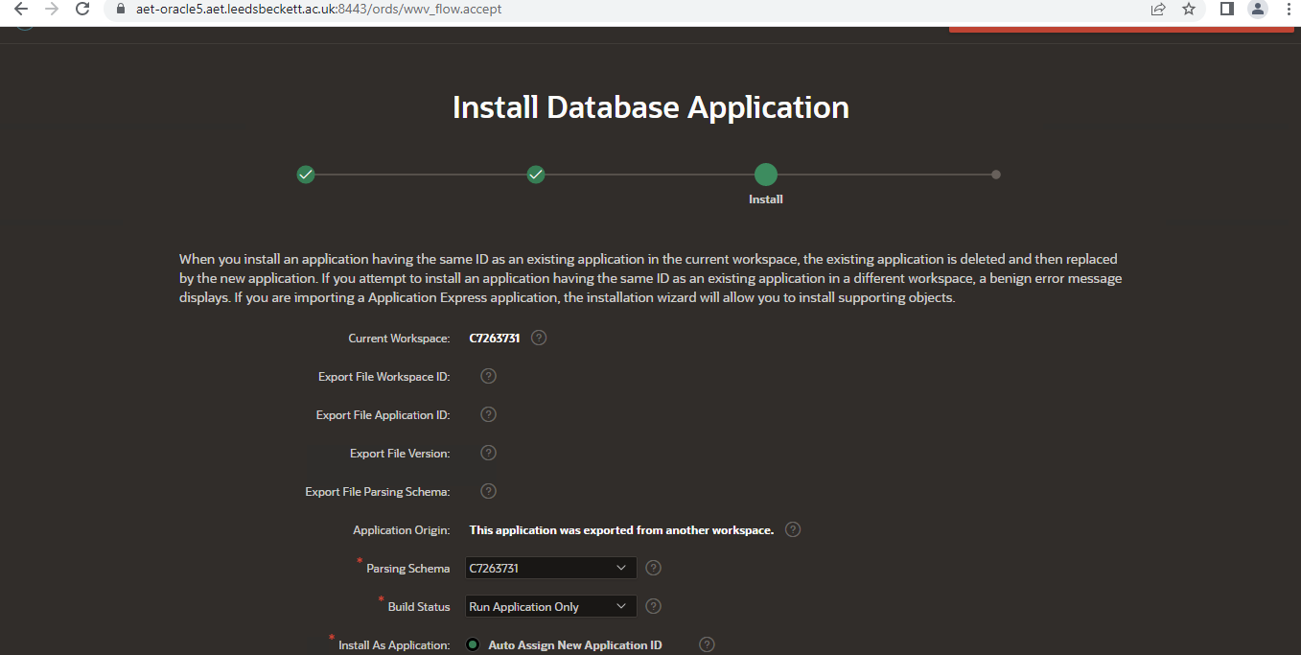

Extracting of data into a temp table?

- You’ll need to move data from a dataset to another dataset, so you can “prepare” data before you enter into the SS. E.g. Code: Insert into temp table as select x, y from original table
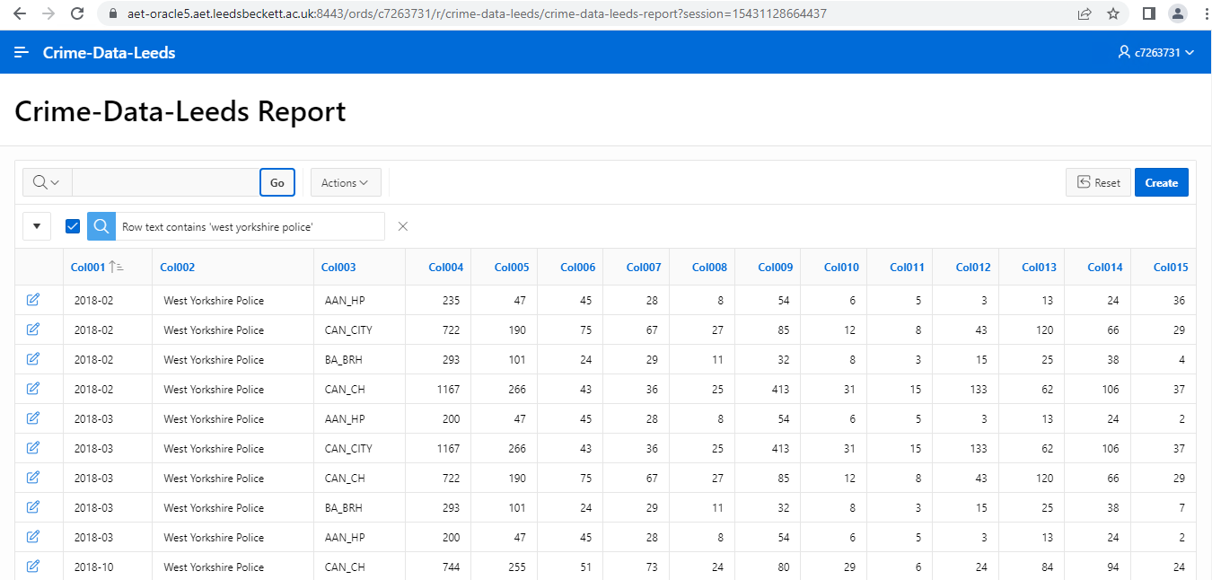

- You can merge two datasets into one – concatenated data sets. These datasets are then cleaned in the next part. E.g. Code@ data x; set dataset1, dataset2, dataset3; run;

- Evidence code, brief discussion and screenshot that it is running successfully
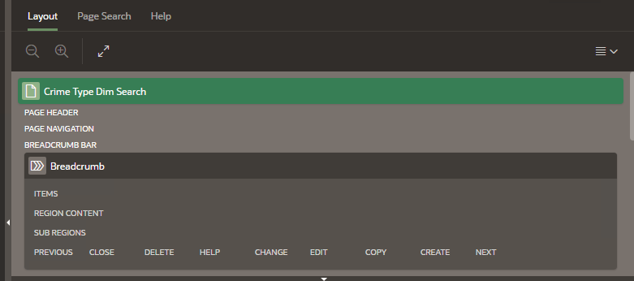

Cleaning of data
- Show here what data were missing data, delete unnecessary data, check if there is incorrect format data?
Answer: data is clean no NA and missing value appear
Answer: No data is missing in crime dataset
- Produce Error log, if any, needed.
Answer: no error log found
- Evidence this by presenting code, brief discussion and screenshot that it is running successfully in Apex.

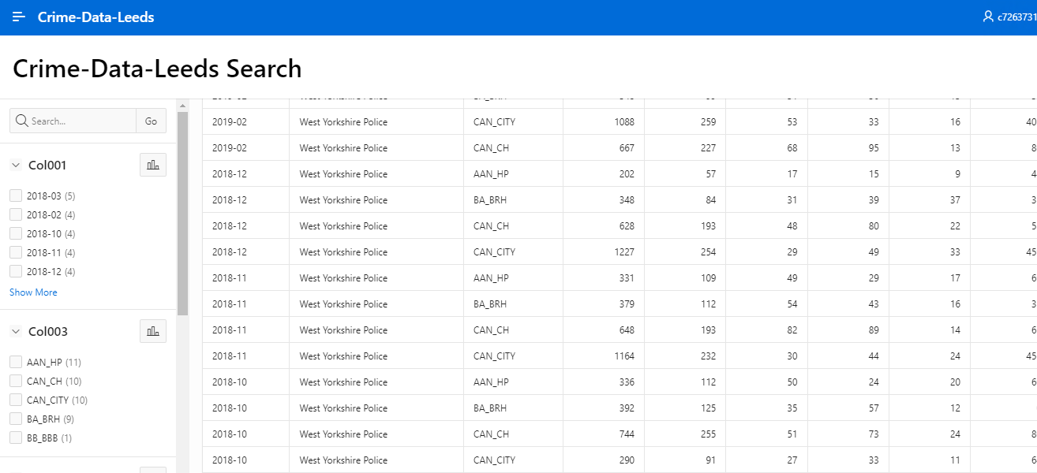

Transforming of data

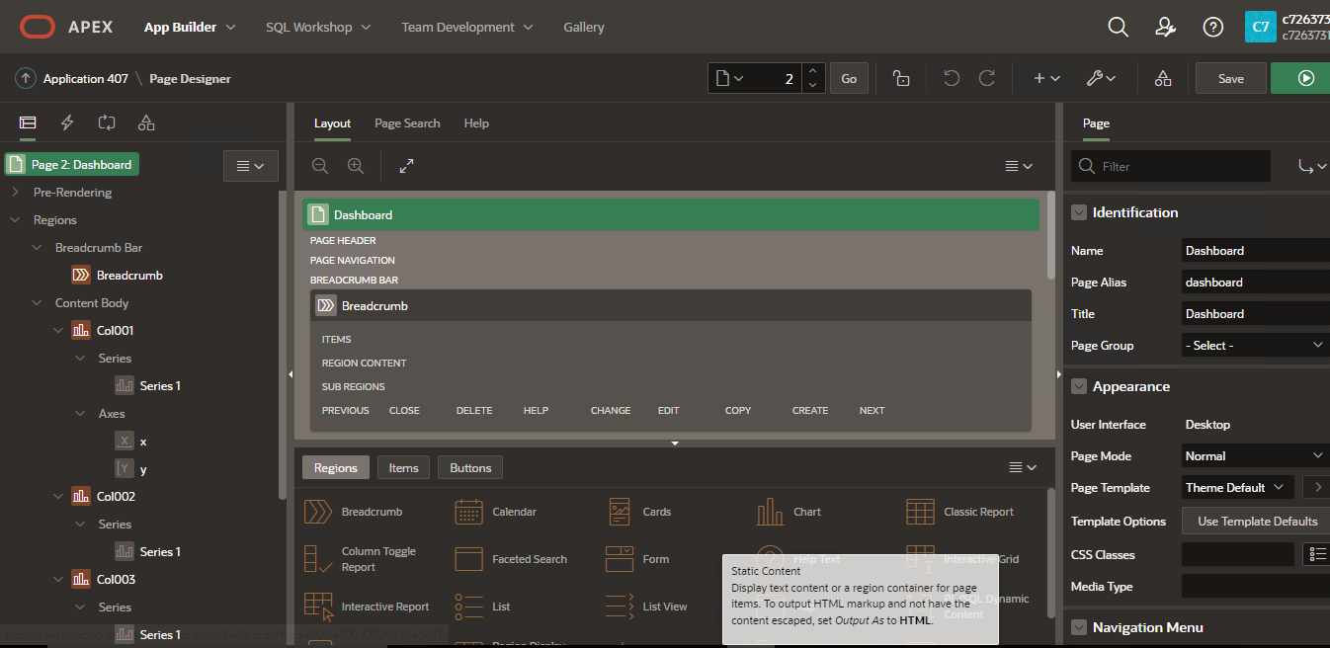
- Evidence code, brief discussion and screenshot that it is running successfully
    - Loading data into SS
- This is cleaned and transformed data!
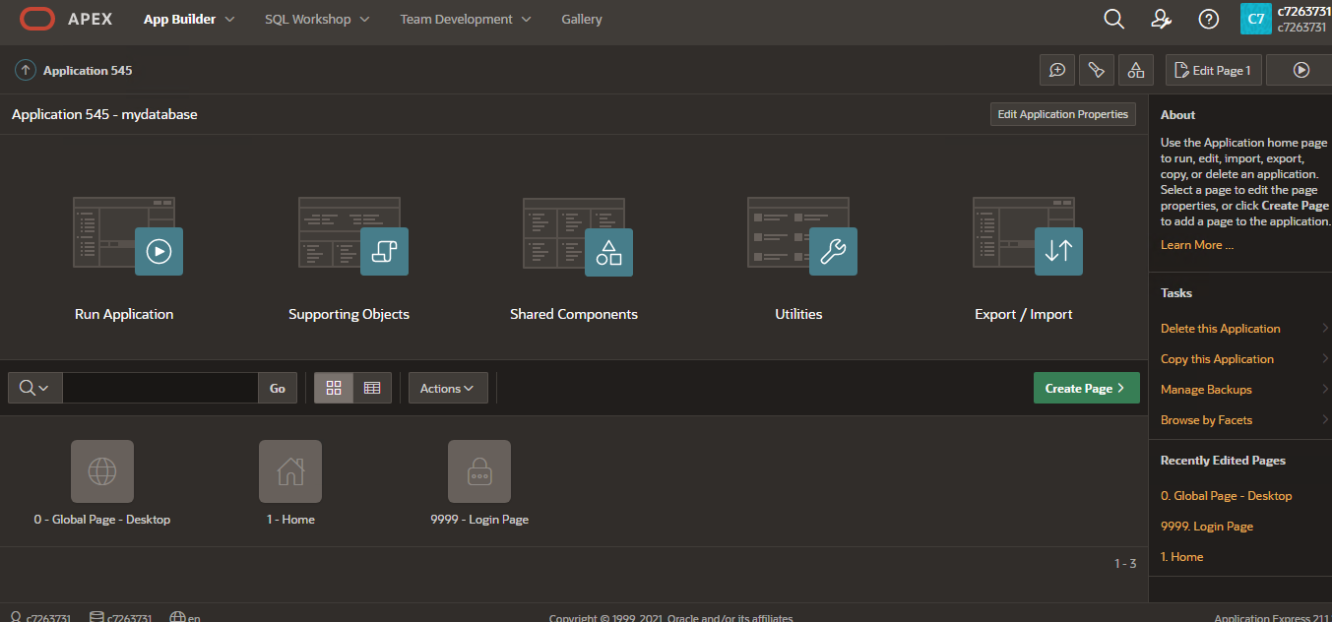
- Clearly show the code for each dataset (dimension) population.
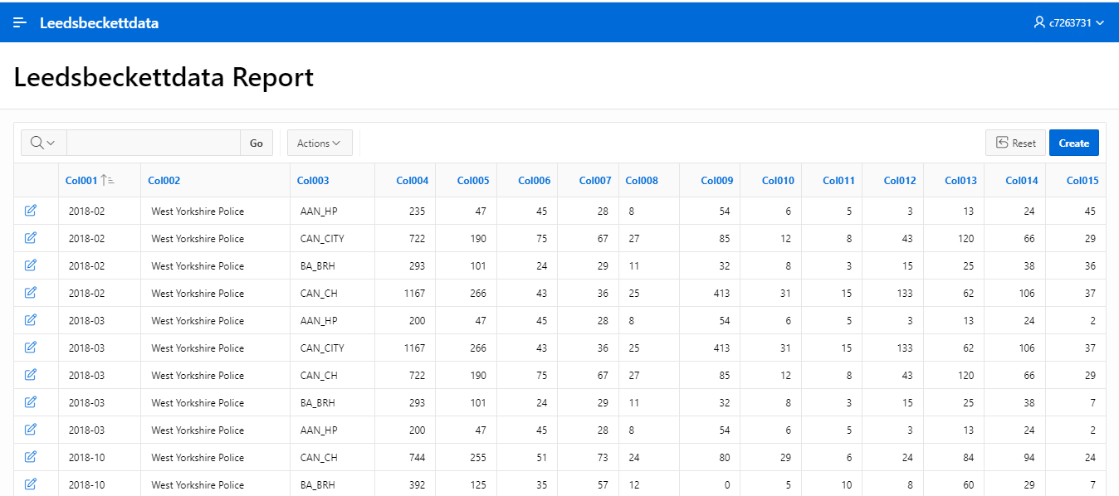

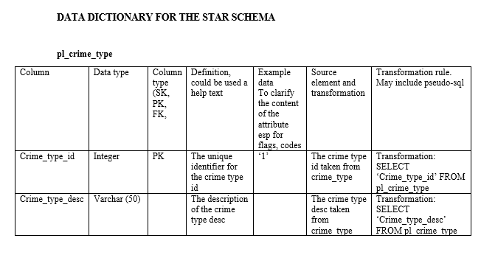
NOTE: you may have chosen to populate dimension directly from the original sources. In any case you will need this part only.
- Evidence code, brief discussion and screenshot that it is running successfully
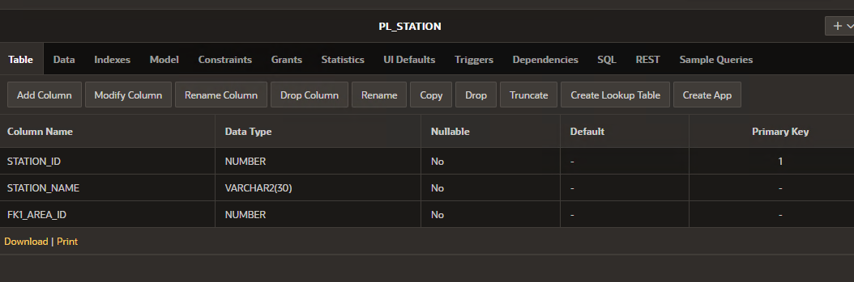
    - Ongoing Data Load (Data Maintenance (SCD)) implemented and evidenced as part to the solution.

TASK 2 - OLAP

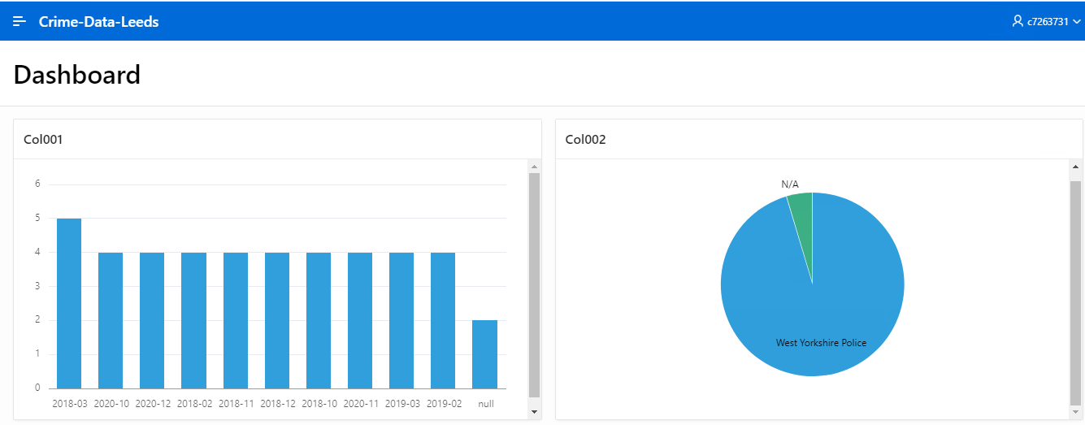

Crime data Leeds chart

- 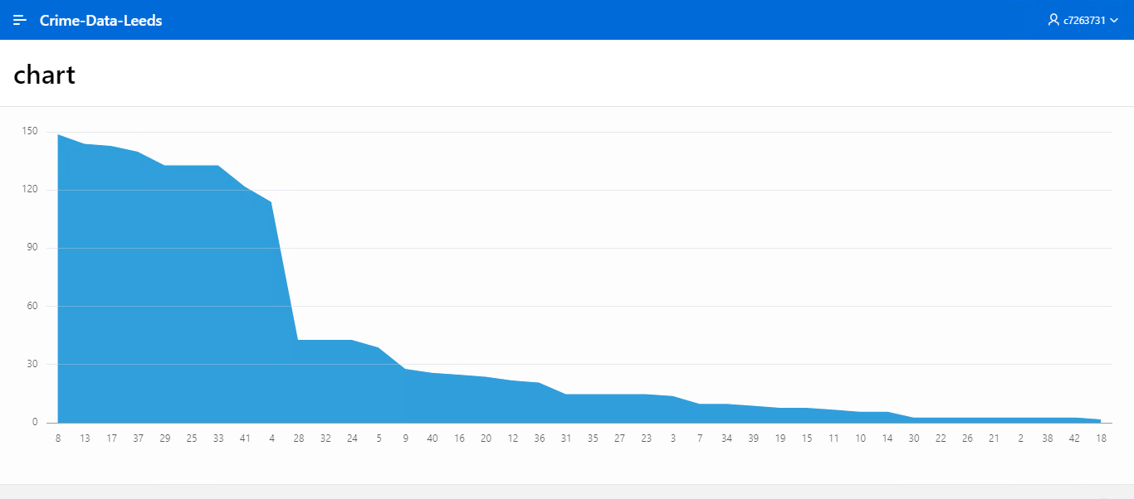
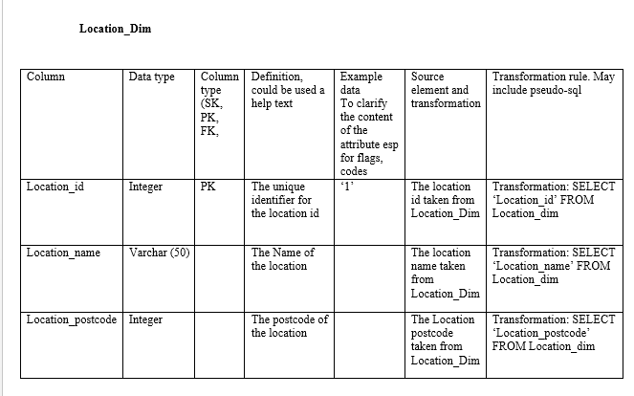
- Decide on the model to use for to support your OLAP. A detailed table or a star schema model (fact and dimensions).

PIVOT Table in Excel
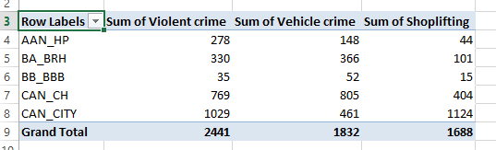
- Design the OLAP investigations (dimensions – eg area: town, city, county and time: week, month, year)
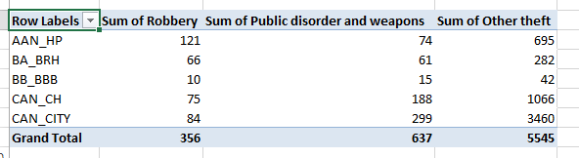
- Create a query in Access (or other software) which can be imported into excel and provide a useful pivot table.
- Create screen shots of the data analysis provided in the pivot table (OLAP as far as this exercise is concerned).
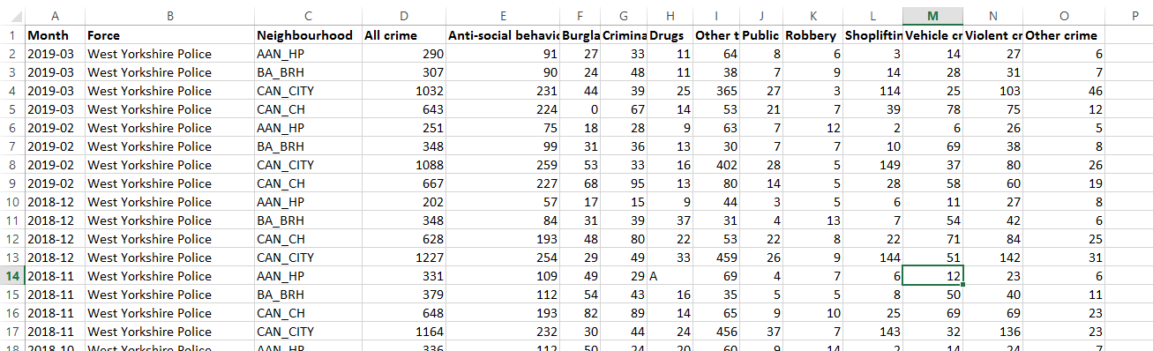

TASK 3 – Findings and Reflection

PAPA framework

Privacy
(Dass, S. and Prabhu, J., 2022) extract transform and load operation oracle tool is amazing to do the big data analytics, databases collected from various locations and process in one data warehousing project. Since the data warehousing projection various complexity and ambiguity has been involved, image data, hybrid data has been merged and combined into one place and processing into the multiple locations due to intelligence of data warehousing scheme. The aim of the studies schemes to analyse the crime dataset in various United Kingdom locations.

Accuracy
The rapidly evolving of database projections, the large variety of data warehousing due to large portion of multiple sources and increasing facts of data which enhance the data availability and data integration process at different time span. Big data tools analyse various task such as merge, sort, mine, and process the information in secure environment. (Mahanti, R., 2021) business organization wants to process and classify the large amounts of data from data management perspectives, since the data warehousing used to process the multiple locations and multiple sites, the crime locations and crime activity has been measured and monitored by crime branch of UK by the way data warehousing.

Property
(Stodder, D., 2018) so far the advance database system now all the application has been migrated to cloud computing environment due to secure and reliability of cloud computing environment. Since the data warehousing used old fashioned mining algorithm technique now the time has been changed due to advance machine learning programming process online OLAP and ETL processing with online processing algorithm to mine the data analytics with less time and more efficient way. Since the OLTP processing of oracle is not so good comparatively to other databases applications. Oracle only support organization internal asset of business applications to process easily on oracle platform.

Accessibility
(Sakr, S. and Zomaya, A.Y. eds., 2019) database management system used in old fashioned processing now the time has been changed mostly the data process at cloud computing environment such as Amazon cloud and Oracle cloud beside this Microsoft cloud playing important role to process the business applications and organization asset. Since the oracle cloud computing process their own applications and third party application needs migration plans so the amazon cloud supporting third party migrated application to process and operate the database system. My personal reflection is truly said that the Amazon cloud computing is much better than oracle data warehousing. So far oracle contains various complexity and issues. Beside this the old fashioned structured query language processing needs complexity to process the large query dataset. So far the third party is better than this projection.

Bibliography
Dass, S. and Prabhu, J., 2022. Amelioration of Big Data Analytics by Employing Big Data Tools and Techniques. In Research Anthology on Big Data Analytics, Architectures, and Applications (pp. 1527-1548). IGI Global.

Mahanti, R., 2021. Data and Its Governance. In Data Governance and Data Management (pp. 5-82). Springer, Singapore.

Sakr, S. and Zomaya, A.Y. eds., 2019. Encyclopedia of big data technologies. Springer International Publishing.

Stodder, D., 2018. BI and Analytics in the Age of AI and Big Data. TDWI Best Practices Report, pp.1-39.
Dinsmore, T.W., 2021. Disruptive Analytics: Charting your strategy for next-generation business analytics. Apress.

Appendixes – add of your APEX code here

CREATE TABLE "PL_STATION"
( "STATION_ID" NUMBER(*,0) NOT NULL ENABLE,
"STATION_NAME" VARCHAR2(30) NOT NULL ENABLE,
"FK1_AREA_ID" NUMBER(*,0) NOT NULL ENABLE,
CONSTRAINT "PK_STATION" PRIMARY KEY ("STATION_ID")
USING INDEX ENABLE
)
/
ALTER TABLE "PL_STATION" ADD CONSTRAINT "FK1_STATION_TO_AREA" FOREIGN KEY ("FK1_AREA_ID")
REFERENCES "PL_AREA" ("AREA_ID") ENABLE
/

Table
Data
Indexes
Model
Constraints
Grants
Statistics
UI Defaults
Triggers
Dependencies
SQL
REST
Sample Queries

CREATE TABLE "CRIME_REGISTER"
( "CRIME_ID" NUMBER(4,0),
"CRIME_NAME" VARCHAR2(20),
"LOCATION_ID" NUMBER(8,0),
"REPORTED_DATE" DATE NOT NULL ENABLE,
"POLICE_ID" NUMBER(4,0),
"CRIME_STATUS" VARCHAR2(8),
"CLOSED_DATE" DATE DEFAULT NULL,
"REPORTER_ID" NUMBER(8,0),
"OFFICER_NOTE" VARCHAR2(128),
"CRIME_TYPE" VARCHAR2(15),
"LINKED_CRIME_ID" NUMBER(8,0),
"DETECTIVE_ID" NUMBER(8,0),
CHECK (crime_status in('OPEN', 'CLOSED', 'open','closed')) ENABLE,
CONSTRAINT "PK_CRIME_REG" PRIMARY KEY ("CRIME_ID")
USING INDEX ENABLE
)
/
ALTER TABLE "CRIME_REGISTER" ADD CONSTRAINT "FK_CRIME_REG_LOC" FOREIGN KEY ("LOCATION_ID")
REFERENCES "LOCATION" ("LOCATION_ID") ON DELETE CASCADE ENABLE
/
ALTER TABLE "CRIME_REGISTER" ADD CONSTRAINT "FK_DETECTIVE" FOREIGN KEY ("DETECTIVE_ID")
REFERENCES "OFFICER" ("OFFICER_ID") ON DELETE CASCADE ENABLE
/
ALTER TABLE "CRIME_REGISTER" ADD CONSTRAINT "FK_OFFICER" FOREIGN KEY ("POLICE_ID")
REFERENCES "OFFICER" ("OFFICER_ID") ON DELETE CASCADE ENABLE
/

CREATE OR REPLACE EDITIONABLE TRIGGER "CRIME_REGISTER_TRIG"
BEFORE INSERT ON CRIME_REGISTER
FOR EACH ROW
BEGIN
IF :NEW.CRIME_id IS NULL THEN
SELECT CRIME_REGISTER_SEQ.NEXTVAL INTO :NEW.CRIME_ID FROM SYS.DUAL;
END IF;
END;

/
ALTER TRIGGER "CRIME_REGISTER_TRIG" ENABLE
/

CREATE TABLE "CRIME_REPORTER"
( "REPORTER_ID" NUMBER,
"REPORTER_NAME" VARCHAR2(35),
"ADDRESS" VARCHAR2(60),
PRIMARY KEY ("REPORTER_ID")
USING INDEX ENABLE
)
/

CREATE TABLE "CRIME_TABLE"
( "ID" NUMBER GENERATED BY DEFAULT ON NULL AS IDENTITY MINVALUE 1 MAXVALUE 9999999999999999999999999999 INCREMENT BY 1 START WITH 1 CACHE 20 NOORDER NOCYCLE NOKEEP NOSCALE NOT NULL ENABLE,
"COL001" VARCHAR2(50),
"COL002" VARCHAR2(50),
"COL003" VARCHAR2(50),
"COL004" NUMBER,
"COL005" NUMBER,
"COL006" NUMBER,
"COL007" NUMBER,
"COL008" NUMBER,
"COL009" NUMBER,
"COL010" NUMBER,
"COL011" NUMBER,
"COL012" NUMBER,
"COL013" NUMBER,
"COL014" NUMBER,
"COL015" NUMBER,
PRIMARY KEY ("ID")
USING INDEX ENABLE
)

Table
Data
Indexes
Model
Constraints
Grants
Statistics
UI Defaults
Triggers
Dependencies
SQL
REST
Sample Queries

CREATE TABLE "LOCATION"
( "LOCATION_ID" NUMBER(8,0),
"HOUSE_NO" NUMBER(4,0) DEFAULT (NULL),
"STREET_NAME" VARCHAR2(32) NOT NULL ENABLE,
"POST_CODE" VARCHAR2(8) NOT NULL ENABLE,
"CITY_NAME" VARCHAR2(32),
"REGION_ID" NUMBER(8,0),
CONSTRAINT "PK_LOCATION" PRIMARY KEY ("LOCATION_ID")
USING INDEX ENABLE,
UNIQUE ("POST_CODE")
USING INDEX ENABLE,
CONSTRAINT "UNIQUE_LOCATION" UNIQUE ("HOUSE_NO", "STREET_NAME", "CITY_NAME")
USING INDEX ENABLE
)
/
ALTER TABLE "LOCATION" ADD CONSTRAINT "FK_REGION" FOREIGN KEY ("REGION_ID")
REFERENCES "REGION" ("REGION_ID") ON DELETE CASCADE ENABLE
/

CREATE OR REPLACE EDITIONABLE TRIGGER "LOCATION_TRIG"
BEFORE INSERT ON LOCATION
FOR EACH ROW
BEGIN
IF :NEW.location_id IS NULL THEN
SELECT LOCATION_SEQ.NEXTVAL INTO :NEW.location_id FROM SYS.DUAL;
END IF;
END;

/
ALTER TRIGGER "LOCATION_TRIG" ENABLE
/
CREATE TABLE "OFFENCE"
( "OFFENCE_ID" NUMBER(8,0),
"OFFENCE_TYPE" VARCHAR2(32) NOT NULL ENABLE,
"FINANCIAL_ID" NUMBER(8,0),
"CRIME_ID" NUMBER(8,0),
CONSTRAINT "PK_OFFENCE" PRIMARY KEY ("OFFENCE_ID")
USING INDEX ENABLE
)
/
ALTER TABLE "OFFENCE" ADD CONSTRAINT "FK_OFFENCE_CRIME_REG" FOREIGN KEY ("CRIME_ID")
REFERENCES "CRIME_REGISTER" ("CRIME_ID") ON DELETE CASCADE ENABLE
/
ALTER TABLE "OFFENCE" ADD CONSTRAINT "FK_OFFENCE_REGION_ID" FOREIGN KEY ("FINANCIAL_ID")
REFERENCES "FINANCIAL" ("FINANCIAL_ID") ON DELETE CASCADE ENABLE
/

CREATE OR REPLACE EDITIONABLE TRIGGER "OFFENCE_TRIG"
BEFORE INSERT ON OFFENCE
FOR EACH ROW
BEGIN
IF :NEW.OFFENCE_id IS NULL THEN
SELECT OFFENCE_SEQ.NEXTVAL INTO :NEW.OFFENCE_ID FROM SYS.DUAL;
END IF;
END;

/
ALTER TRIGGER "OFFENCE_TRIG" ENABLE
/
CREATE TABLE "OFFICER"
( "OFFICER_ID" NUMBER(8,0),
"FIRST_NAME" VARCHAR2(32),
"MIDDLE_NAME" VARCHAR2(32) DEFAULT NULL,
"LAST_NAME" VARCHAR2(32),
"DOB" DATE,
"GENDER" VARCHAR2(8),
"DEPARTMENT" VARCHAR2(32),
"RANK" NUMBER(8,0),
CONSTRAINT "PK_OFFICER" PRIMARY KEY ("OFFICER_ID")
USING INDEX ENABLE
)
/

CREATE OR REPLACE EDITIONABLE TRIGGER "OFFICER_TRIG"
BEFORE INSERT ON OFFICER
FOR EACH ROW
BEGIN
IF :NEW.officer_id IS NULL THEN
SELECT OFFICER_SEQ.NEXTVAL INTO :NEW.OFFICER_id FROM SYS.DUAL;
END IF;
END;

/
ALTER TRIGGER "OFFICER_TRIG"

CREATE TABLE "PL_AREA"
( "AREA_ID" NUMBER(*,0) NOT NULL ENABLE,
"AREA_NAME" VARCHAR2(30) NOT NULL ENABLE,
"PARENT_AREA" NUMBER(*,0),
CONSTRAINT "PK_AREA" PRIMARY KEY ("AREA_ID")
USING INDEX ENABLE,
UNIQUE ("AREA_NAME")
USING INDEX ENABLE
)
/
ALTER TABLE "PL_AREA" ADD CONSTRAINT "FK_AREA_TO_AREA" FOREIGN KEY ("PARENT_AREA")
REFERENCES "PL_AREA" ("AREA_ID") ENABLE
/

CREATE TABLE "PL_CRIME_TYPE"
( "CRIME_TYPE_ID" NUMBER(*,0) NOT NULL ENABLE,
"CRIME_TYPE_DESC" VARCHAR2(50) NOT NULL ENABLE,
CONSTRAINT "PK_CRIME_TYPE" PRIMARY KEY ("CRIME_TYPE_ID")
USING INDEX ENABLE
)
/

CREATE TABLE "PL_POLICE_EMPLOYEE"
( "EMP_ID" NUMBER(*,0) NOT NULL ENABLE,
"EMP_NAME" VARCHAR2(30) NOT NULL ENABLE,
"EMP_GRADE" NUMBER(*,0) NOT NULL ENABLE,
CONSTRAINT "PK_POLICE_EMP" PRIMARY KEY ("EMP_ID")
USING INDEX ENABLE
)
/
CREATE TABLE "PL_REPORTED_CRIME"
( "REPORTED_CRIME_ID" NUMBER(*,0) NOT NULL ENABLE,
"DATE_REPORTED" DATE NOT NULL ENABLE,
"CRIME_POSTCODE" VARCHAR2(16) NOT NULL ENABLE,
"CRIME_STATUS" VARCHAR2(16) NOT NULL ENABLE,
"DATE_CLOSED" VARCHAR2(20),
"FK1_CRIME_TYPE_ID" NUMBER(*,0) NOT NULL ENABLE,
"FK2_STATION_ID" NUMBER(*,0) NOT NULL ENABLE,
CONSTRAINT "PK_REPORTED_CRIME" PRIMARY KEY ("REPORTED_CRIME_ID")
USING INDEX ENABLE
)
/
ALTER TABLE "PL_REPORTED_CRIME" ADD CONSTRAINT "FK1_RC_TO_CTYPE" FOREIGN KEY ("FK1_CRIME_TYPE_ID")
REFERENCES "PL_CRIME_TYPE" ("CRIME_TYPE_ID") ENABLE
/
ALTER TABLE "PL_REPORTED_CRIME" ADD CONSTRAINT "FK2_REPORTED_CRIME_TO_STATION" FOREIGN KEY ("FK2_STATION_ID")
REFERENCES "PL_STATION" ("STATION_ID") ENABLE
/

CREATE TABLE "PL_STATEMENT"
( "S_REPORTED_CRIME_ID" NUMBER(*,0) NOT NULL ENABLE,
"D_WITNESS_ID" NUMBER(*,0) NOT NULL ENABLE,
"STATEMENT_TYPE" VARCHAR2(30) NOT NULL ENABLE,
"STATEMENT_LOCATION" VARCHAR2(50) NOT NULL ENABLE,
PRIMARY KEY ("S_REPORTED_CRIME_ID", "D_WITNESS_ID")
USING INDEX ENABLE
)
/
ALTER TABLE "PL_STATEMENT" ADD FOREIGN KEY ("S_REPORTED_CRIME_ID")
REFERENCES "PL_REPORTED_CRIME" ("REPORTED_CRIME_ID") ENABLE
/
CREATE TABLE "PL_WORK_ALLOCATION"
( "S_REPORTED_CRIME_ID" NUMBER(*,0) NOT NULL ENABLE,
"D_EMP_ID" NUMBER(*,0) NOT NULL ENABLE,
"WORK_DESC" VARCHAR2(50) NOT NULL ENABLE,
"LEAD_POLICE_OFFICER" NUMBER(*,0) NOT NULL ENABLE,
"WORK_START_DATE" DATE NOT NULL ENABLE,
"WORK_END_DATE" DATE NOT NULL ENABLE,
PRIMARY KEY ("S_REPORTED_CRIME_ID", "D_EMP_ID")
USING INDEX ENABLE
)
/
ALTER TABLE "PL_WORK_ALLOCATION" ADD FOREIGN KEY ("S_REPORTED_CRIME_ID")
REFERENCES "PL_REPORTED_CRIME" ("REPORTED_CRIME_ID") ENABLE
/
ALTER TABLE "PL_WORK_ALLOCATION" ADD FOREIGN KEY ("D_EMP_ID")
REFERENCES "PL_POLICE_EMPLOYEE" ("EMP_ID") ENABLE
/

